PROGRAM
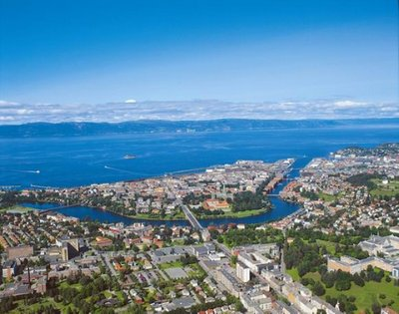

Educational Systems
and Human Capital

Workshop in Trondheim
27-29 March 2011

SUNDAY MARCH 27
19:30. Dinner

MONDAY MARCH 28

8:30-9:30. Keynote presentation
Chair: Torberg Falch
Hessel Oosterbeek
Education interventions in developing countries

9:45-11:15. Session 1A. Returns to schooling
Chair: Jon Fiva
Elena Crivellaro: Lost in transition? The returns to education acquired under communism 15 years after the fall of the Berlin Wall
Discussant: Monique de Haan
Manudeep Bhuller: Life-cycle bias and the returns to schooling in current and lifetime earnings
Discussant: Kåre Johansen

9:45-11:15. Session 1B. Norwegian schools
Chair: Edwin Leuven
Arnt Ove Hopland: School facilities and student achievement
Discussant: Lars Monkerud
Astrid M. J. Sandsør: Early school start and child outcomes
Discussant: Elke Lüdemann

11:30-12:15. Session 2A. Peer effects
Chair: Torberg Falch
Jon Marius Vaag Iversen: Gender peer effects and school controlling mechanisms
Discussant: Edwin Leuven

11:30-12:15. Session 2B. Pedagogy
Chair: Bjarne Strøm
Johan Coenen: Do activating educational methods improve early career labor market outcomes?
Discussant: Elena Crivellaro

12:15-13:30. Lunch

13:30-15:00. Session 3
Chair: Sofia Sandgren Massih
James Vernoit: The effects of moving to more autonomous school structures: Academy schools and their introduction in English education.
Discussant: Fredrik Carlsen
Marijn Verschelde: School autonomy and educational performance: Within-country evidence
Discussant: Bjarne Strøm

15:30-17:00. Session 4
Chair: Bjarne Strøm
Kaja Høiseth Brugård: High school attainment, student achievement, and imprisonment
Discussant: Mikael Lindahl
Monique de Haan: Scale economies can offset the benefits of competition: Evidence from a school consolidation reform in a universal voucher system
Discussant: Jørn Rattsø

19:30. Dinner
TUESDAY MARCH 29

8:30-9:30. Keynote presentation
Chair: Hans Bonesrønning
Mikael Lindahl
Transmission of human capital across four generations: intergenerational correlations and a test of the Becker-Tomes theory

9:45-11:15. Session 5A: Teacher behavior
Chair: Lars Monkerud
Krzysztof Karbownik: What determines the teacher mobility in Sweden?
Discussant: Torberg Falch
Edwin Leuven: Estimation of preferences for job attributes using job-to-job mobility: Teacher turnover and school characteristics
Discussant: Johan Coenen

9:45-11:15. Session 5B: Classmate influence
Chair: Marte Rønning
Marianne Haraldsvik: Peer effects on student achievement: How important is the educational level of the classmates’ parents?
Discussant: Jon Fiva
Marc Piopiunik: Do teachers really grade on a curve? Evidence from within-student variation
Discussant: Jon Marius Vaag Iversen

11:30-12:15. Session 6A. Exit exam
Chair: Rune Borgan Reiling
Elke Lüdemann: Intended and unintended short-term effects of the introduction of central exit exams: Evidence from Germany
Discussant: Hans Bonesrønning

11:30-12:15. Session 6B. Birth month
Chair: Trude Gunnes
Ingeborg Foldøy Solli: Birth month and long term outcomes
Discussant: Sofia Sandgren Massih

12:15-13:30. Lunch

13:30-15:00. Session 7
Chair: Torberg Falch
Helge Sandvig Thorsen: Too cool for school? Evidence of declining quality of teachers
Discussant: Marte Rønning
Jon H. Fiva: The effects of paternity leave on parents and children
Discussant: Hessel Oosterbeek

